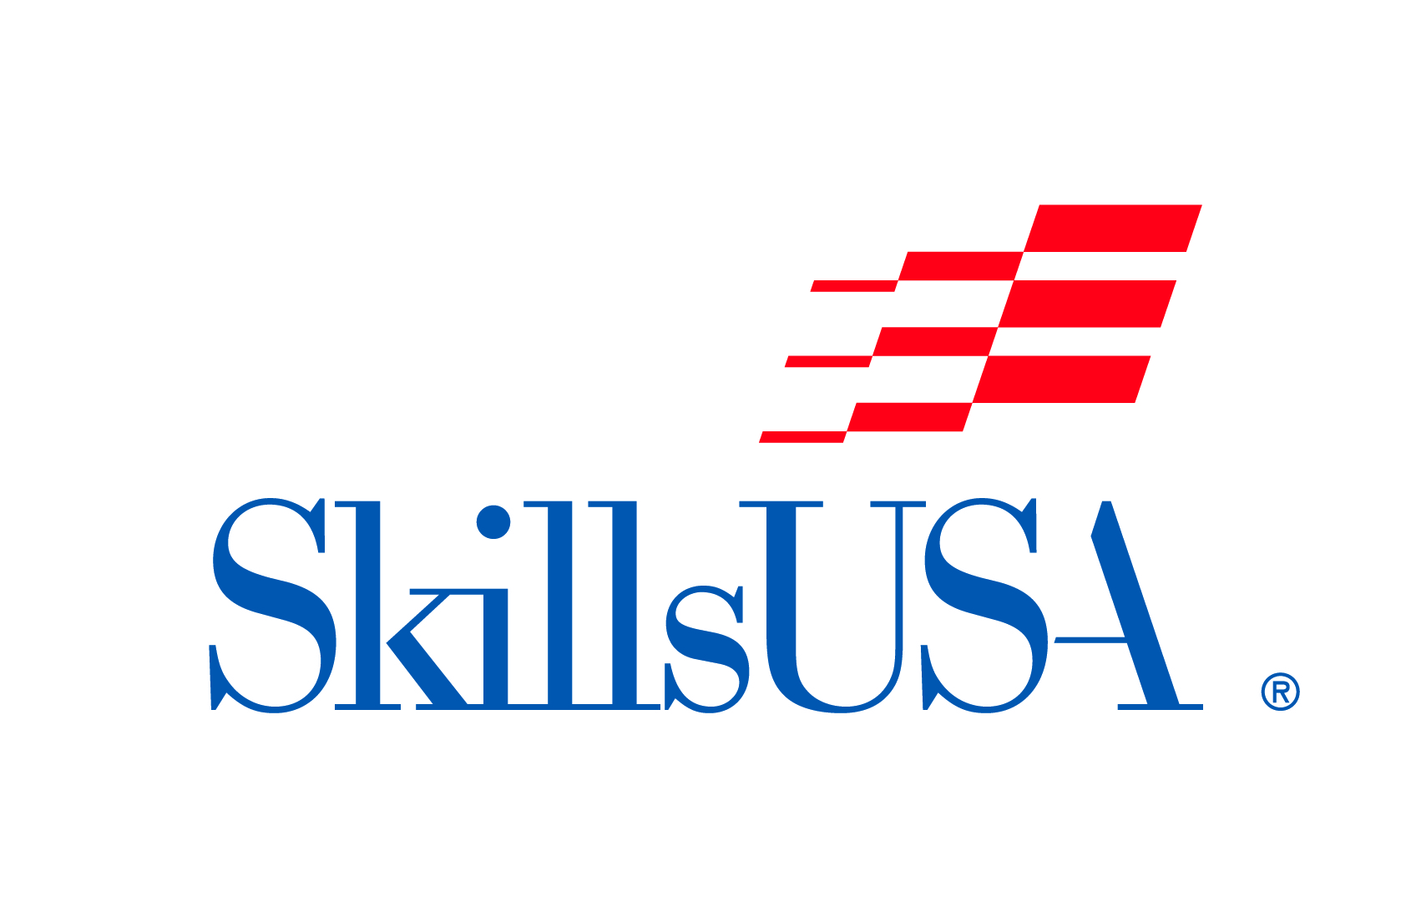
NLSC 2023 Social Media Toolkit

Social Media Toolkit Graphics Folder- This folder contains all the graphics that are individually linked below.

Pre-Conference Information/Hype
Post | Copy | Graphic | Platform | Post
1 | Build, connect, and celebrate all while exploring what Atlanta has to offer during the National Leadership & Skills Conference June 19-23  .  .  .  #SkillsUSA #OurTimeIsNow #NLSC23 | Graphic | Facebook  Instagram
2 | The city of Atlanta is excited to host the 2023 National Leadership & Skills Conference. The safety and security of our members is the number one priority. Hear from city officials who are working to ensure we have a successful conference.  .  .  .  #SkillsUSA #OurTimeIsNow #NLSC23 | Graphic | Facebook  Instagram

Post-SLSC Recognition and Excitement
Post | Copy | Graphic | Platform | Post
1 | SkillsUSA [state] is excited to recognize [member name] who will be attending NLSC 2022 to participate in [contest/event]. [Add additional bio here.]  .  .  .  #SkillsUSA #OurTimeIsNow #NLSC23  *Instructions*  -Create a free Canva Account  -On the right hand panel, upload the desired photo  -Click, drag, and drop to replace the current photo within the photo frame  -Click on the text to replace the name  -Download as a PNG | Graphic | Facebook  Instagram
2 | Atlanta is calling our delegates, competitors, advisors, and partners to the largest showcase of the skilled trades. Will we see you at the National Leadership & Skills Conference this June?  .  .  .  #SkillsUSA #OurTimeIsNow #NLSC23 | Graphic | Facebook  Instagram | 50 days out from NLSC -April 30th, 2023
3 | SkillsUSA [state] is excited to recognize [advisor name], SkillsUSA advisor who will be attending NLSC 2022 to participate in [Engage, Academies of Excellence, Advisor Summit and/or SkillsUSA University. ]. [Add additional bio here.]  .  .  .  #SkillsUSA #OurTimeIsNow #NLSC23  *Instructions*  -Create a free Canva Account  -On the right hand panel, upload the desired photo  -Click, drag, and drop to replace the current photo within the photo frame  -Click on the text to replace the name  -Download as a PNG | Graphic | Facebook  Instagram
4 | Have you started packing yet? The National Leadership and Skills Conference will be here before you know it. Make sure to check off these list items to be prepared for an exciting week!  .  .  .  #SkillsUSA #OurTimeIsNow #NLSC23 | Graphic | Facebook  Instagram
5 | Network, compete, explore, and discover all that the National Leadership & Skills Conference has in store! Check out the Call to Conference video for a sneak peak of what’s to come.  .  .  .  #SkillsUSA #OurTimeIsNow #NLSC23 | Graphic

On-Site At NLSC
Post | Copy | Graphic | Platform | Post
3 | Today our competitors put their skills, hard work, and preparation to the test as competitions begin! Good luck to all of our competitors representing [insert state]  .  .  .  #SkillsUSA #OurTimeIsNow #NLSC23 | Graphic | Facebook  Instagram
5 | Congratulations to our state delegation on their performance this week at the National Leadership & Skills Conference. [state] brought home [number] medals from SkillsUSA Championships, celebrated [chapter] as a Model of Excellence Chapter, elected [name] as a national officer, and are grateful to our [number] members who served as voting delegates. Great work, [state]!  .  .  .  #SkillsUSA #OurTimeIsNow #NLSC23 | Graphic | Facebook  Instagram

